G.V.Sai Kiran
18114026

problem statement-1
Write a menu driven program as follows:
1. To insert a node in the BST and in the red-black tree
2. To create AVL tree from the inorder traversal of the BST
3. To print the inorder traversal of the BST/AVL/red-black tree
4. To display all the paths in the BST/AVL tree/red-black tree
5. To print the BST/AVL tree/red-black Tree in the terminal using level-wise indentation (print color
for red-black tree)
6. Exit
l3p1.cpp
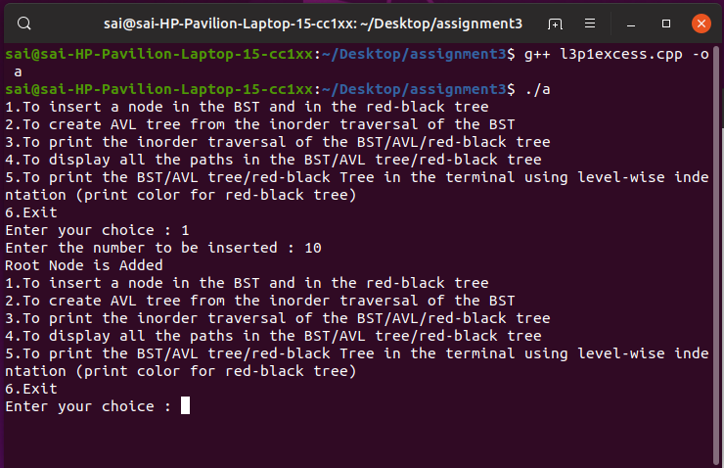
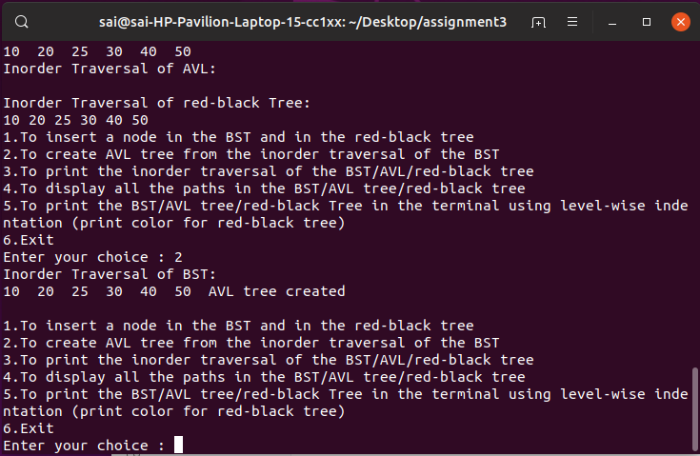
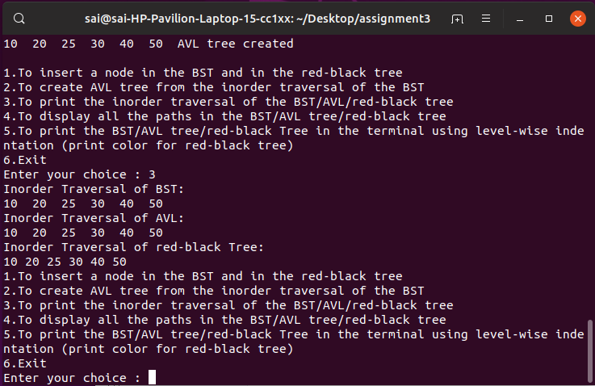
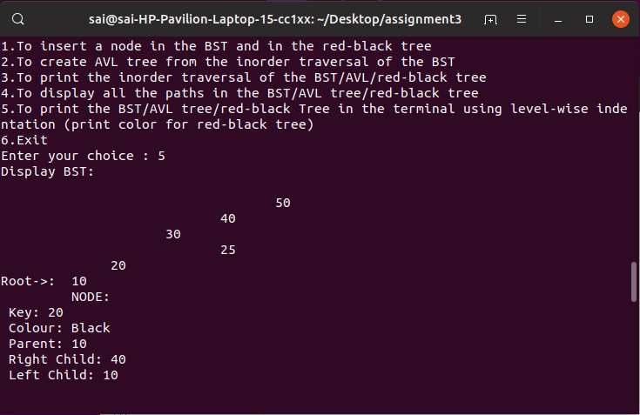
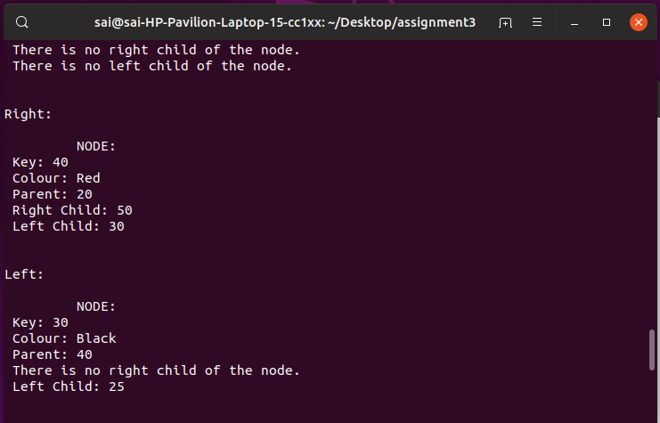
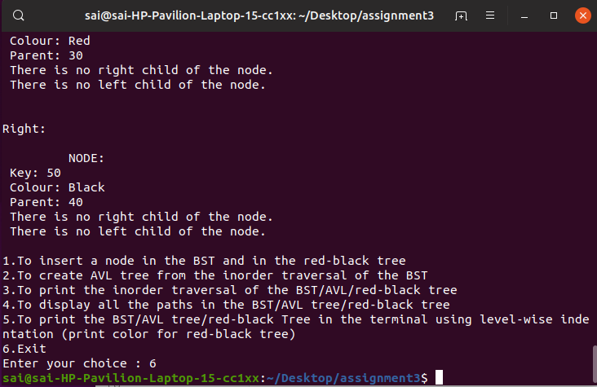
Problem 2:
For a given sequence of positive integers A 1 , A 2 , ..., A N in decimal, find the triples (i, j, k), such
that 1 ≤ i < j ≤ k ≤ N and A i ⊕A i+1 ⊕...⊕A j−1 = A j ⊕A j+1 ⊕...⊕A k, where ⊕ denotes bitwise XOR.
This problem should be solved using dynamic programming approach and linked list data
structures.
Input:
(a) Number of positive integers N.
(b) N space-separated integers A 1 , A 2 , ..., A N .
Output:
Print the number (count) of triples and list all the triplets in lexicographic order (each triplet in a
new line).
L3p2.cpp
